**COLOR DETECTION**

**A PROJECT REPORT**

*Submitted by*

**KOLLI GOPINADH**

*Under the Guidance of*

**DR. P. C. KARTHIK**

(Assistant Professor, Department of Computer Science and Engineering) *In partial fulfillment of the Requirements for the Degree of* **BACHELOR OF TECHNOLOGY**

**DEPARTMENT OF COMPUTER SCIENCE AND ENGINEERING**

**FACULTY OF ENGINEERING AND TECHNOLOGY SRM INSTITUTE OF SCIENCE AND TECHNOLOGY KATTANKULATHUR – 603203**

**NOVEMBER 2022**



SRM INSTITUTE OF SCIENCE AND TECHNOLOGY KATTANKULATHUR-603203

BONAFIDE CERTIFICATE

Certified that this project report titled “**COLOR DETECTION”** is the bonafide work of **“KOLLI GOPINADH” [Reg No: RA2011042010121]** carried out the project work under my supervision. Certified further, that to the best of my knowledge the work reported herein does not form part of any other thesis or dissertation on the basis of which a degree or award was conferred on an earlier occasion for this or any other candidate.

Dr. P. C. KARTHIK HOD

Staff -Incharge

Signature of Internal Examiner Signature of External Examiner

# ABSTRACT

The main objective of this application is the methodology for identifying the shades of colors with an exact prediction of their names. A study says a normal human can able to identify nearly 1 million shades of colors clearly. But in the case of humans having “enchroma”, could be able to see only 1% (i.e.10,000 colors) of normal humans. While painting pictures, a painter needs to identify the color patterns exactly, or else the reality of the image is not apparent.

# INTRODUCTION

Before going into the speculations of the project it is important to know the definition of color detection. It is simply the process of identifying the name of any color. It is obvious that humans perform this action naturally and do not put any effort into doing so. While it is not the case for computers.

Human eyes and brain work in coordination in order to translate light into color. Light receptors that are present in the eyes transmit the signal to the brain which in turn recognizes the color. There is no exaggeration in saying that humans have mapped certain lights with their color names since childhood. The same strategy is useful in detecting color names in this project.

Three different colors Red, Green, and Blue are being tracked by utilizing the fundamentals of computer vision. After successful compilation when we execute the code a window redirects to the image displayed on

it whose path is given as an argument.

Additionally, we obtain the color name of the pixel along with the composition of three different colors red, blue, and green values. It is helpful in recognizing colors and in robotics. One of the applications of color detection by computer vision is in driverless cars. This system is useful in detecting traffic and vehicle backlights and takes decisions to stop, start and continue driving.

This also has much application in industry to pick and place different colored objects by the robotic arm. Color detection is also used as a tool in various image editing and drawing apps.

# METHODS AND MATERIAL

## Image Capture:

The first step is to fetch a high-quality image with resolution. To load an image from a file we use Cv2.imread(). The image should be in the working directory or the full path of the image should be given. Img=cv2.imread(img path)

## Extraction of RGB Colors:

In this phase, the 3 layered colors are extracted from the input image. All the color images on screens such as televisions, computers, monitors, laptops, and mobile screens are produced by the combination of Red, Green, and Blue light.

Each primary color takes an intensive value from 0 (lowest) to 255 (highest). When mixing 3 primary colors at different intensity levels a variety of colors are produced. For Example: If the intensity value of the primary colors is 0, this linear combination corresponds to black. If the intensity value of the primary colors is 1, this linear combination corresponds to white.

**Index=[ "color", "color_name", "hex", "R", "G", "B"]**

## Calculate minimum distance from coordinates:

The minimum distance is calculated by considering moving towards the origin point from all colors to get the most matching color.

The panda's library serves as an important utility to perform various operations on comma-separated values like PD.read_csv() reads the CSV file and loads it into the panda's data frame.

**D = abs(R-int(CSV.loc[i, "R"])) + abs (G-int (CSV. loc[i, "G"]))**

**+ abs (B- int (CSV.loc [i, "B"]))**

## Image Display with Shades of Color:

The rectangle window is used to display the image with shades of color. After the double-click is triggered, the RGB values and color name is updated.

To display an image Cv2.imshow () method is used. By using the cv2.rectangle and cv2.putText () functions, the color name and its intensity level can be obtained.

**text=getColorName(r,g,b) + 'R='+str(r) + 'G='+str(g) + 'B='**

**+str(b).**

# SYSTEM ARCHITECTURE

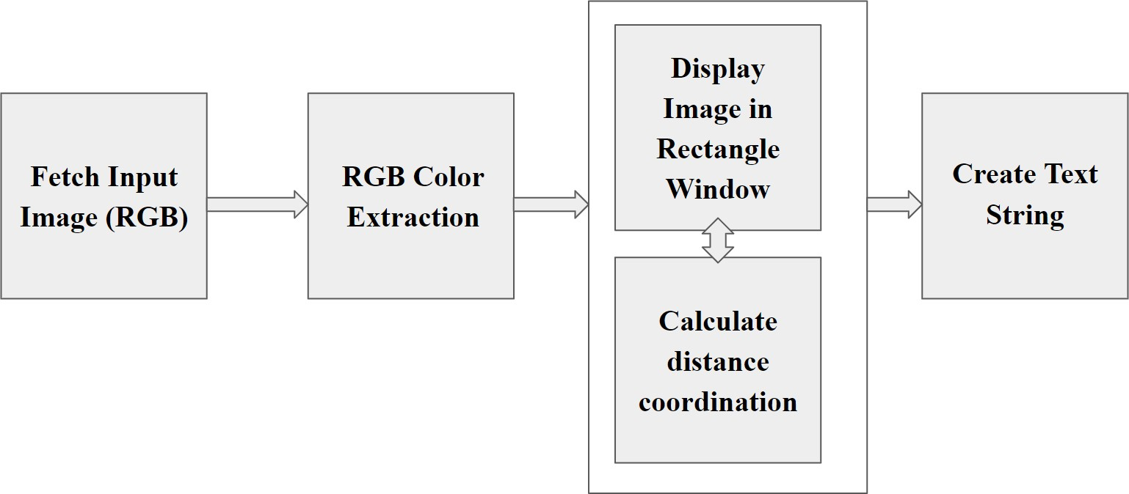

Figure III(1): Architecture Diagram

The above architecture shows the capability of the project. It consists of a well-defined sequence diagram that is abstracted from the source code. It leverages the rich capabilities of technology such as the OpenCV library in python. The above architecture makes the process more efficient based on principles and properties related to each other. As we know Red, Green and Blue are the primary colors that can be mixed to produce different colors. The present color detection project takes the path of an image as an input and looks for the composition of three different colors red, green, and blue in the given image.

# LIBRARIES USED

## Pandas:

Pandas is an open-source, BSD-authorized Python library giving superior, simple-to-utilize information designs and information examination devices for the Python programming language. Python with Pandas is utilized in a wide scope of fields including scholastic and business spaces including money, financial matters, Statistics, investigation, and so forth. It is used for the manipulation of data and provides a number of tools for the analysis of data. It grants fast and flexible data structures which makes it easier to work with tabular data and time series.

## OpenCV:

OpenCV is the huge open-source library for computer vision, machine learning, and image processing and now it plays a major role in real-time operation which is very important in today’s systems. By using it, one can process images and videos to identify objects, faces, or even the handwriting of a human. When it is integrated with various libraries, such as NumPy, python is capable of processing the OpenCV array structure for analysis. To Identify an image pattern and its various features we use vector space and perform mathematical operations on these features.

# EXPERIMENTAL RESULTS

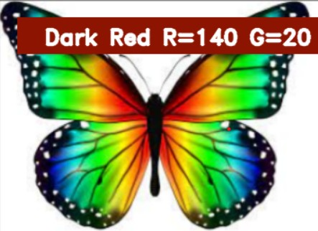

Figure V(1)

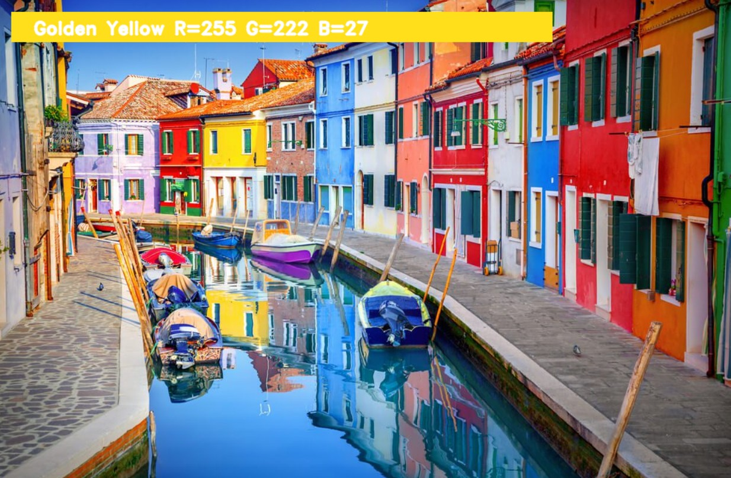

Figure V(2)

# CONCLUSION

In this, we defined to get the required color field from an RGB image. In this various steps are implemented using the OpenCV platform. The main positive point of this method is its color differentiation of a mono color. In the future scope, the detection of edge detection techniques has different other applications like facial detection, color conversion for greyscale images, etc. that can also be implemented.

# FUTURE WORK

In the existing system, there is no exact color representation of colors with accuracy. In the proposed system, we are introducing the CV datasets and according to it the number of shades that can be identified using 865 color names along with their RGB and hex values. Whenever the cursor clicks the image, it automatically shows the RGB shade's color values. The proposed system uses OpenCV for sorting primary colors.